VEK280 Vitis-AI Machine Learning Deployment
and YOLOv7 Performance Evaluation
Project Technical Report
AMD Versal AI Edge VEK280 / VE2802 • Vitis 2025.2 • Vitis-AI 6.2
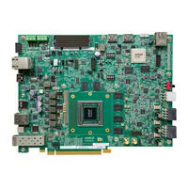
Figure 1. AMD Versal AI Edge VEK280 evaluation board.

1. Project Overview
This project evaluates machine-learning inference on the AMD Versal AI Edge VEK280 evaluation board (VE2802 device) using AMD Vitis, Vitis-AI and the Neural Processing Unit (NPU). The main objective was to move practical deep-learning models from a host development environment to an embedded accelerator, run them on the board, and measure inference performance, end-to-end throughput and power-related metrics.
The main model investigated in this work is YOLOv7, an object-detection network. ResNet50 and YOLOX were also brought up successfully and used as supporting validation models. The report therefore gives only a short introduction to those models and concentrates on YOLOv7 deployment, profiling, source-resolution experiments and camera testing.

2. Why VEK280 Instead of a Normal Computer?
A conventional CPU-based computer is general-purpose and can execute neural networks, but an embedded AI accelerator is designed to perform neural-network operations with much higher hardware parallelism and with a power/performance focus. The VEK280 combines a Versal Adaptive SoC with programmable logic, processing-system resources and an AI Engine-ML array. AMD documents the VEK280 as a platform for AI/ML acceleration and identifies the VE2802 device and its AIE-ML architecture as key parts of the board.
For this project, the important advantage is that the trained network is converted into an NPU-executable representation and the heavy neural-network computation is performed by the accelerator rather than relying only on the host CPU.
Project-level reasons for using VEK280:
- Dedicated NPU acceleration for neural-network inference.
- AIE-ML and programmable-logic resources suitable for accelerated AI pipelines.
- Embedded operation: inference can run locally on the board after deployment.
- Ability to measure latency, throughput and accelerator-related power on real hardware.
- Supports a deployment flow in which existing ML models can be prepared on the host and executed on the target.

3. VEK280 Hardware
The VEK280 is built around the AMD Versal AI Edge VE2802 Adaptive SoC. The board documentation identifies the VE2802 device, 12 GB LPDDR4 memory, MicroSD boot/storage, Ethernet, USB/JTAG, HDMI, FMC+, PCIe and other high-speed interfaces. The VE2802 AIE-ML array used by the project configuration contains 38 columns × 8 rows (304 AIE-ML tiles).
Component | Role | Project relevance
VE2802 Versal Adaptive SoC | Main compute device | Contains PS, PL and AIE-ML resources used by the AI pipeline
AI Engine-ML array | Parallel ML/DSP compute | Core acceleration resource used by the NPU
Programmable Logic (PL) | Hardware datapath / interfaces | Part of the NPU and surrounding acceleration pipeline
Processing System (PS) | Runs embedded Linux and applications | Controls inference and system software
12 GB LPDDR4 | External working memory | Stores application/model data and buffers
MicroSD | Boot and image storage | Used for board software, snapshots and system files
Ethernet | Host-board networking | Used for SSH/file transfer during development
USB/JTAG/serial | Debug and console | Used for board bring-up and debugging
HDMI / camera interfaces | I/O | Useful for display and vision pipelines
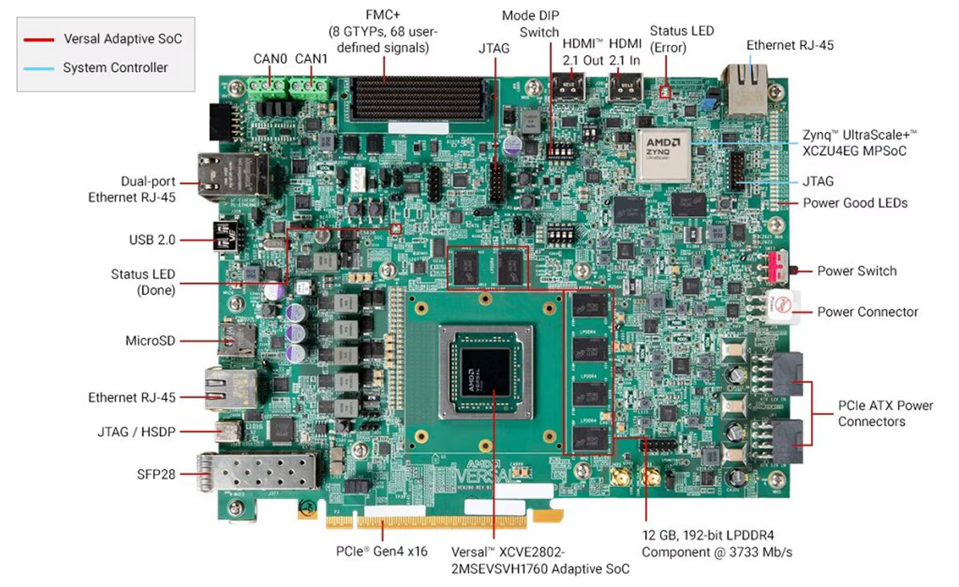
Figure 2. VEK280 board with its main hardware components and interfaces labeled.

4. Physical Connections Used
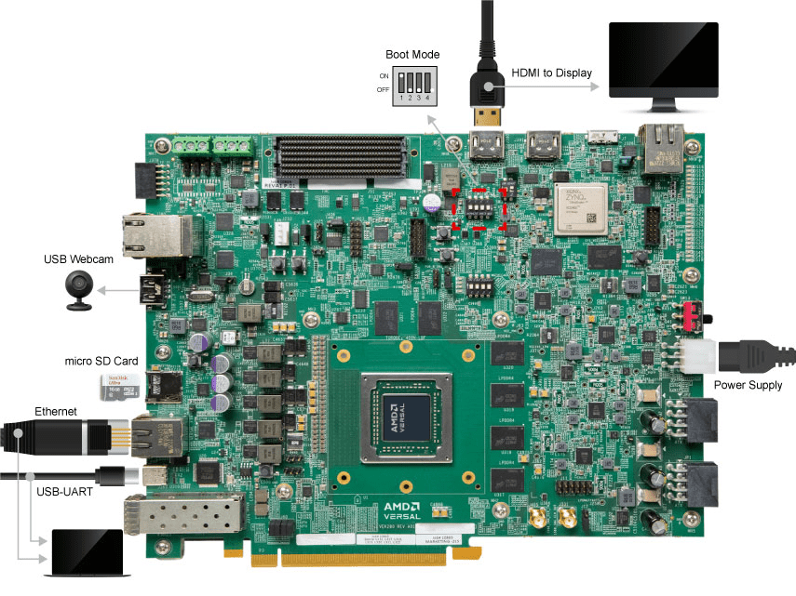
Typical project setup: the VEK280 is powered from its supplied power input, boots from the MicroSD card, connects to the host PC over Ethernet for SSH/data transfer, and uses USB/JTAG/serial for console and debug. The exact interface used for a particular camera or display pipeline can vary.

5. Software Setup / Quick Start
The project environment used the following major software components:
- Ubuntu x86_64 host system.
- AMD Vitis 2025.2.
- AMD Vitis-AI 6.2.
- PetaLinux 2025.2 board image/reference design.
- VE2802 NPU IP configuration: VE2802_NPU_IP_O00_A304_M3.
- Vitis-AI software runtime / VART components on the board.
- Python 3.12.x for host-side model work and Python 3.12.11 on the board.

5.1 Host-side setup
source ~/vek280/2025.2/Vitis/settings64.sh
cd ~/vek280/vitis-ai-6.2/Vitis-AI
source npu_ip/settings.sh
source tools/VAI_NPU_SW/settings.sh
For the project, the selected NPU configuration was VE2802_NPU_IP_O00_A304_M3. AMD's Vitis-AI documentation lists this configuration as the default active NPU IP for the VE2802 family.

5.2 Board bring-up and connection
sudo minicom -D /dev/ttyUSB1 -b 115200
ip link set end0 up
ip addr add 192.168.1.85/24 dev end0
ping 192.168.1.52
The 192.168.1.85 address was the board address used during the working Ethernet phase of the project; the host was 192.168.1.52. These addresses describe the project's lab setup and are not required values for every deployment.

6. How an ML Model Is Ported to the VEK280
The important concept is that a .pt file is not copied to the board and executed directly as a normal PyTorch program. The model is prepared on the host for the target NPU. The resulting snapshot contains the information needed by the NPU runtime, including the network structure, weights, calibration information and input-size information.
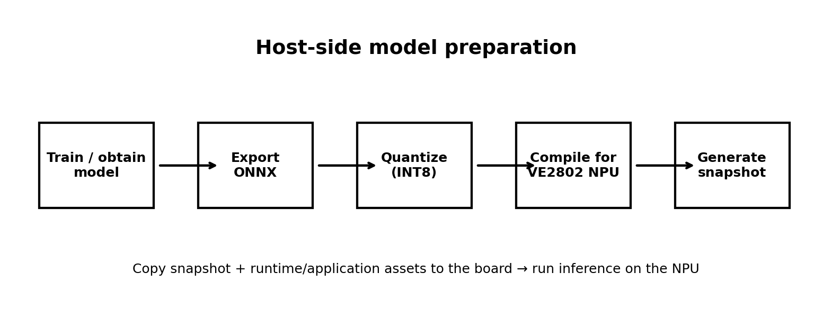
1. Model preparation: Start from a trained model such as YOLOv7. Export/convert it to a supported representation such as ONNX where required.
2. Quantization: The network is quantized for accelerator execution. In this project the key NPU precision is INT8.
3. Compilation: The quantized network is compiled/mapped for the selected VE2802 NPU IP configuration.
4. Snapshot generation: A Vitis-AI snapshot is produced on the x86 host. The snapshot is the deployable model representation used by the NPU runtime.
5. Deployment: The snapshot and supporting runtime/application files are copied to the board's storage.
6. Inference: A VART/NPU-based application loads the snapshot and sends input tensors to the accelerator.
7. Post-processing: For YOLOv7, detection decoding and NMS are performed after the neural-network output is produced.

6.1 Where does the ML model run?
During inference, the computationally intensive neural-network operations are executed by the NPU, which uses the VE2802's programmable-logic and AI Engine-ML resources. The embedded CPU/processing system runs Linux, the inference application and control/runtime tasks. Memory such as LPDDR4 is used for model data, input/output buffers and intermediate data. Pre-processing and post-processing can be implemented in software or hardware depending on the application.

7. Models Tested
Model | Task | Project status | Role in report
ResNet50 | Image classification | Successfully tested | Brief validation / introductory result
YOLOX-S | Object detection | Successfully tested | Brief validation / introductory result
YOLOv7 | Object detection | Successfully tested and profiled | Main focus: deployment, profiling, source resolution and camera testing

8. YOLOv7 Deployment
YOLOv7 was the primary object-detection model evaluated on the VEK280. The deployed snapshot was generated for the VE2802 NPU IP configuration and stored on the board at:
/run/media/mmcblk0p1/snapshot.VE2802_NPU_IP_O00_A304_M3.yolov7.TF
The project detector used a fixed model input of 640×640, confidence threshold 0.25 and NMS IoU threshold 0.45. Therefore, changing the source image/video resolution did not change the NPU input tensor size; the source frame was prepared for the fixed 640×640 model input.

8.1 Example inference command
source /etc/vai.sh
python3 /root/yolov7_detect.py --snapshot /run/media/mmcblk0p1/snapshot.VE2802_NPU_IP_O00_A304_M3.yolov7.TF --image /root/cat.jpg --output /root/yolov7_result.jpg --conf 0.25

9. YOLOv7 Performance Profiling
A 100-image baseline profile was completed using the YOLOv7 detector. The model input remained 640×640. The measured mean NPU latency was approximately 63.114 ms, corresponding to approximately 15.844 NPU FPS. The measured end-to-end throughput was approximately 0.315 FPS. The large difference between NPU FPS and end-to-end FPS shows that the complete application pipeline—input handling, preprocessing, inference, post-processing, image output and other software overhead—was much slower than the accelerator inference alone.
Metric | Value | Test | Interpretation
Mean NPU latency | 63.114 ms | 100 images | Neural-network accelerator latency
NPU throughput | 15.844 FPS | 100 images | Approx. 1 / NPU latency
End-to-end throughput | 0.315 FPS | 100 images | Complete application pipeline
Idle power | 3.309 W | INA226 rail | Rail measurement
Active power | 3.299 W | INA226 rail | Rail measurement
Peak power | 3.411 W | INA226 rail | Rail measurement
Energy | 1046.867 J total | 100 images | Equivalent to 10.46867 J/image
Power note: these INA226 figures are measurements of the monitored rail used in the experiment, not a claim of total VEK280 board power consumption.

10. Source-Resolution Experiment
To determine whether camera/source resolution significantly changed NPU performance, 100 images were tested at each of four source resolutions: 320×240, 640×480, 1280×720 and 1920×1080. All 400/400 test images completed successfully. The neural-network input remained fixed at 640×640.
Source resolution | NPU latency (ms) | NPU FPS | E2E FPS | INA226 power (W) | Energy/image (J)
320×240 | 62.924 | 15.892 | 0.311 | 3.3297 | 10.697
640×480 | 62.808 | 15.922 | 0.329 | 3.3146 | 10.082
1280×720 | 62.696 | 15.950 | 0.308 | 3.2958 | 10.707
1920×1080 | 57.422 | 17.415 | 0.304 | 3.3020 | 10.875
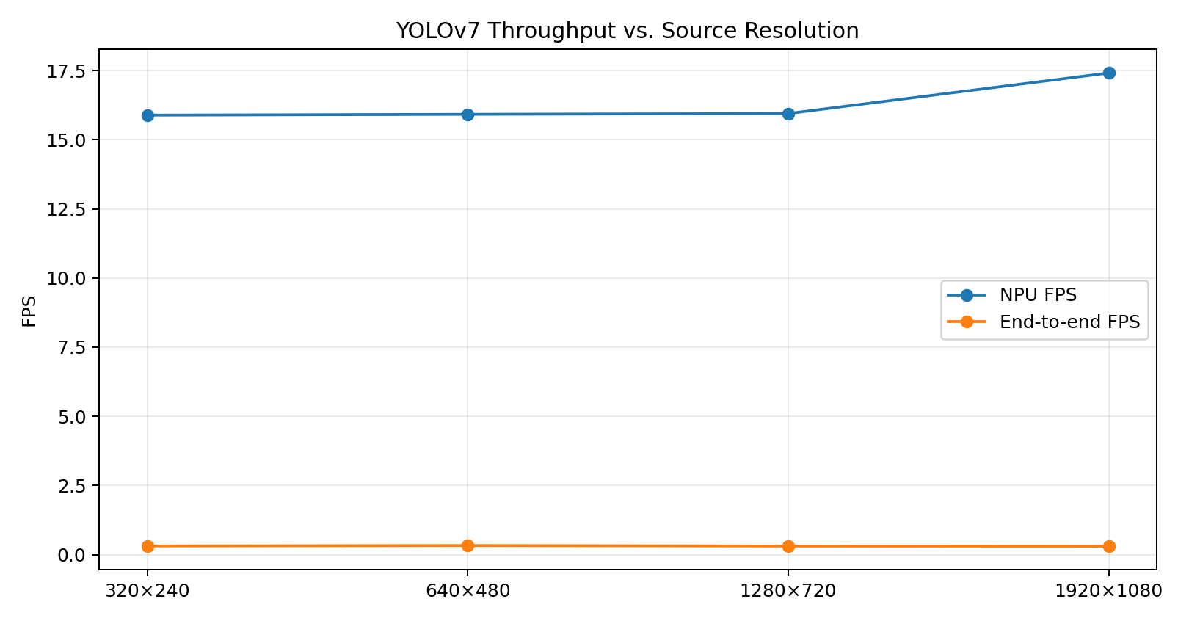
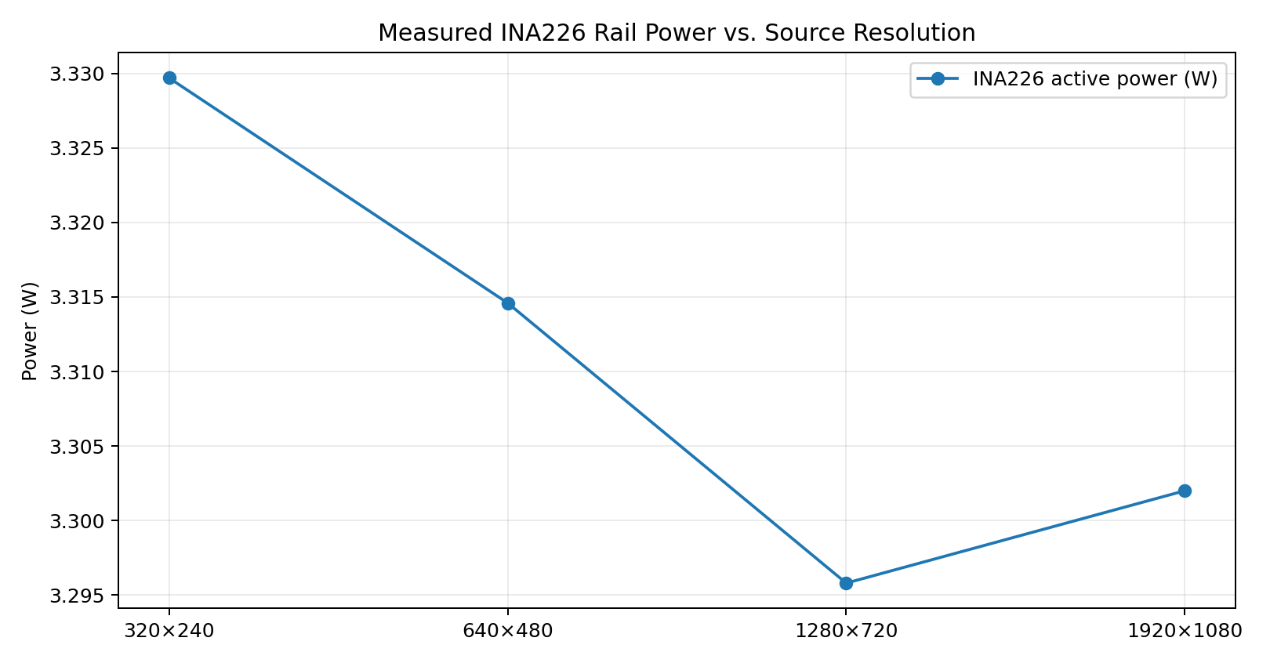
Observation: the NPU-side latency stayed in roughly the same range across the four source resolutions because the model itself continued to receive a fixed 640×640 input. The end-to-end rate remained around 0.3 FPS, indicating that software and pipeline overhead dominated the complete application throughput in this test.

11. Video / Webcam Testing

11.1 Recorded video baseline
A recorded traffic-sign video, /root/yellow_traffic_signs.avi, was used as a repeatable baseline. The video contained 211 frames at 640×480 and approximately 30 FPS source rate.
Metric | Result | Notes
Frames processed | 211 / 211 | 100% successful
Source | 640×480, ~30 FPS | 7.033 s source duration
Total processing time | 640.188 s | Complete application processing
Mean NPU latency | 63.195 ms | 61.120–64.190 ms observed range
NPU throughput | 15.824 FPS | Accelerator-side
End-to-end throughput | 0.330 FPS | Complete pipeline
Real-time ratio | 0.0110 | Much slower than source real-time rate

11.2 Live webcam test
A Logitech Pro 9000 webcam at /dev/video0 was tested at 640×480 and 30 FPS. A 100-frame live-camera capture was processed to measure the behavior of the complete camera-to-inference pipeline.
Metric | Result | Notes
Frames processed | 100 | Live camera test
Camera | Logitech Pro 9000 (/dev/video0) | 640×480, 30 FPS
Total processing time | 320.975 s | 100-frame run
Mean NPU latency | 70.380 ms | 65.540–77.620 ms
NPU throughput | 14.209 FPS | Accelerator-side
End-to-end throughput | 0.312 FPS | Complete camera pipeline
The webcam experiment confirms that the NPU itself can process frames at around 14–15 FPS for this deployment, while the complete camera pipeline was around 0.31 FPS in the measured setup. Therefore, the main optimization opportunity is not simply increasing the NPU clock; it is reducing software, capture, preprocessing, post-processing and I/O overhead around the accelerator.

12. YOLOv7 Test Methodology Summary
- Target: AMD Versal AI Edge VEK280 / VE2802.
- NPU IP: VE2802_NPU_IP_O00_A304_M3.
- YOLOv7 snapshot: snapshot.VE2802_NPU_IP_O00_A304_M3.yolov7.TF.
- Model input: fixed 640×640.
- Confidence threshold: 0.25.
- NMS IoU threshold: 0.45.
- Source-resolution experiment: 100 images × 4 resolutions = 400 images.
- Recorded-video test: 211 frames at 640×480.
- Webcam test: 100 frames at 640×480, 30 FPS source.
- Power instrumentation: INA226 monitored rail; values should not be interpreted as total board power.

13. Key Findings
- The VEK280 successfully executed the YOLOv7 model through the Vitis-AI NPU deployment flow.
- The NPU-side YOLOv7 inference latency was approximately 57–63 ms in the source-resolution experiment, with a measured NPU throughput up to 17.415 FPS in the 1920×1080 source case.
- Changing source resolution had relatively little effect on NPU latency because the model input remained fixed at 640×640.
- End-to-end throughput was approximately 0.30–0.33 FPS in the tested software pipeline, substantially below NPU-only throughput.
- The recorded-video and webcam experiments demonstrated the same general separation between accelerator throughput and complete application throughput.
- The measured INA226 rail power stayed around 3.30–3.33 W during the source-resolution experiment; these are rail measurements, not total-board power figures.
- The work demonstrates the complete path from ML model preparation and INT8-oriented NPU deployment to real-hardware inference and performance measurement.

14. Conclusion
The project established a working Vitis-AI deployment flow on the VEK280 and demonstrated real-hardware execution of multiple ML models. ResNet50 and YOLOX provided initial validation, while YOLOv7 was used for the detailed study. The YOLOv7 work covered single-image inference, repeatable image profiling, source-resolution testing, recorded-video processing and live webcam capture.
The most important performance observation is the distinction between NPU inference speed and application-level throughput. The NPU was able to execute the YOLOv7 network at roughly 14–17 FPS in the measured tests, whereas the complete software pipeline achieved only about 0.3 FPS. This makes pipeline optimization—especially input capture, preprocessing, memory movement, post-processing and output handling—a major next step for improving real-world throughput.

15. References
- AMD VEK280 Evaluation Board User Guide (UG1612): Board features and interfaces.
- AMD VEK280 Evaluation Kit Flyer / Product Brief: board overview and included hardware.
- AMD Vitis-AI Documentation — Software Installations / Quick Start.
- AMD Vitis-AI Documentation — Default Reference Design / X+ML architecture.
- AMD Vitis Getting Started documentation for VEK280.
Official documentation links:
https://docs.amd.com/r/en-US/ug1612-vek280-eval-bd/Board-Features
https://vitisai.docs.amd.com/projects/gen1/en/latest/docs/quickstart/install.html
https://vitisai.docs.amd.com/projects/gen1/en/latest/docs/customization_opportunities/default-reference.html
https://docs.amd.com/r/en-US/Vitis-Tutorials-Getting-Started/Vitis-Platform

